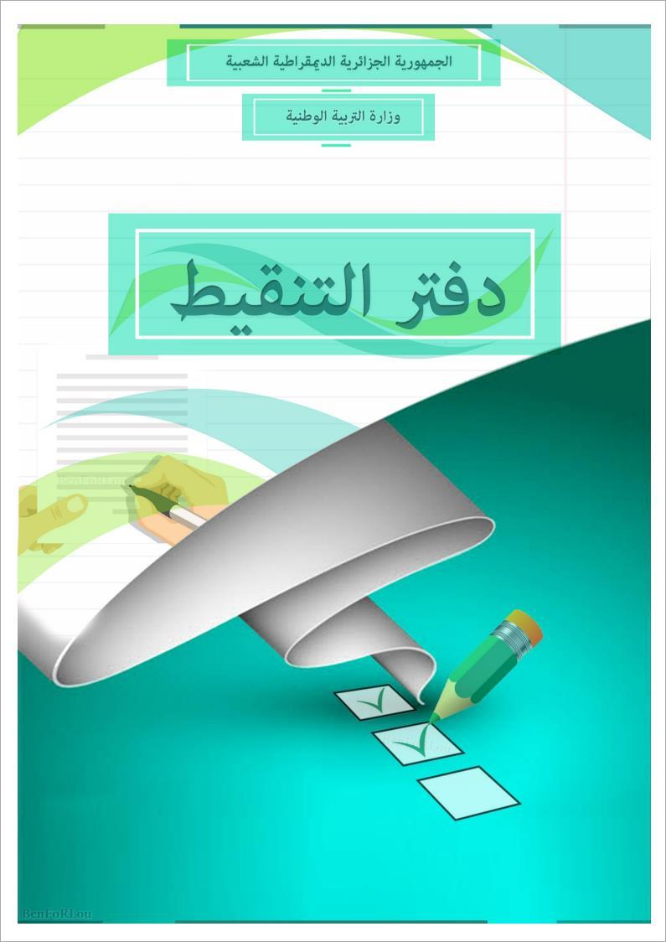

**القسم : ................. الفصل : ................**

|  |  |  |  |  |  |  |  |  |  |  |  |  |  |  |
| --- | --- | --- | --- | --- | --- | --- | --- | --- | --- | --- | --- | --- | --- | --- |
|  | **اللقب و الإسم** | **المراقبة المستمرة** | | | | | | | | | | **الفرض** | **الإختبار** | **المعدل** |
|  | **المواظبة و الإنظباط** | | | **المردود داخل القسم** | | | **المردود خارج القسم** | | | **المجموع** |
|  |
|  |
|  |  |  |  |  |  |  |  |  |  |
| **1** |  |  |  |  |  |  |  |  |  |  |  |  |  |  |
| **2** |  |  |  |  |  |  |  |  |  |  |  |  |  |  |
| **3** |  |  |  |  |  |  |  |  |  |  |  |  |  |  |
| **4** |  |  |  |  |  |  |  |  |  |  |  |  |  |  |
| **5** |  |  |  |  |  |  |  |  |  |  |  |  |  |  |
| **6** |  |  |  |  |  |  |  |  |  |  |  |  |  |  |
| **7** |  |  |  |  |  |  |  |  |  |  |  |  |  |  |
| **8** |  |  |  |  |  |  |  |  |  |  |  |  |  |  |
| **9** |  |  |  |  |  |  |  |  |  |  |  |  |  |  |
| **10** |  |  |  |  |  |  |  |  |  |  |  |  |  |  |
| **11** |  |  |  |  |  |  |  |  |  |  |  |  |  |  |
| **12** |  |  |  |  |  |  |  |  |  |  |  |  |  |  |
| **13** |  |  |  |  |  |  |  |  |  |  |  |  |  |  |
| **14** |  |  |  |  |  |  |  |  |  |  |  |  |  |  |
| **15** |  |  |  |  |  |  |  |  |  |  |  |  |  |  |
| **16** |  |  |  |  |  |  |  |  |  |  |  |  |  |  |
| **17** |  |  |  |  |  |  |  |  |  |  |  |  |  |  |
| **18** |  |  |  |  |  |  |  |  |  |  |  |  |  |  |
| **19** |  |  |  |  |  |  |  |  |  |  |  |  |  |  |
| **20** |  |  |  |  |  |  |  |  |  |  |  |  |  |  |
| **21** |  |  |  |  |  |  |  |  |  |  |  |  |  |  |
| **22** |  |  |  |  |  |  |  |  |  |  |  |  |  |  |
| **23** |  |  |  |  |  |  |  |  |  |  |  |  |  |  |
| **24** |  |  |  |  |  |  |  |  |  |  |  |  |  |  |
| **25** |  |  |  |  |  |  |  |  |  |  |  |  |  |  |
| **26** |  |  |  |  |  |  |  |  |  |  |  |  |  |  |
| **27** |  |  |  |  |  |  |  |  |  |  |  |  |  |  |
| **28** |  |  |  |  |  |  |  |  |  |  |  |  |  |  |
| **29** |  |  |  |  |  |  |  |  |  |  |  |  |  |  |
| **30** |  |  |  |  |  |  |  |  |  |  |  |  |  |  |
| **31** |  |  |  |  |  |  |  |  |  |  |  |  |  |  |
| **32** |  |  |  |  |  |  |  |  |  |  |  |  |  |  |
| **33** |  |  |  |  |  |  |  |  |  |  |  |  |  |  |
| **34** |  |  |  |  |  |  |  |  |  |  |  |  |  |  |
| **35** |  |  |  |  |  |  |  |  |  |  |  |  |  |  |
| **36** |  |  |  |  |  |  |  |  |  |  |  |  |  |  |